Norwich Walk

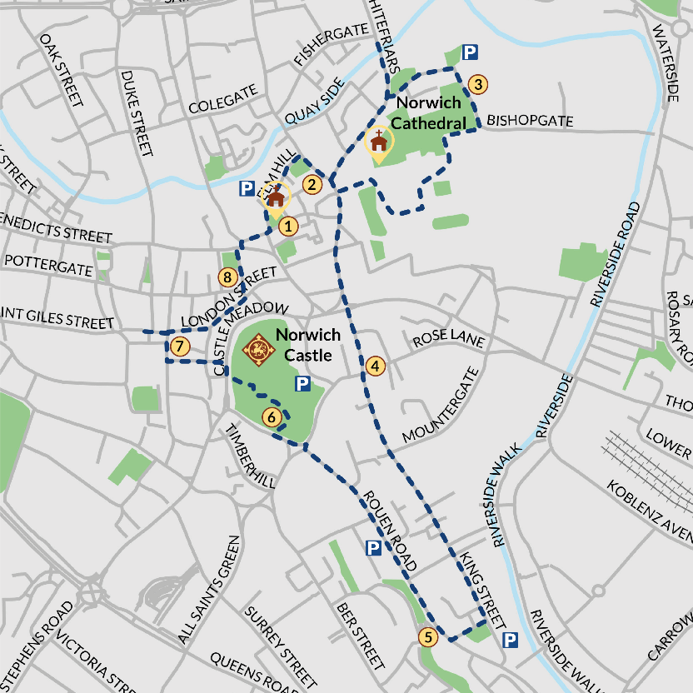
SHORT ROUTE: stops 1 – 3.

STOP 1: St Peter Hungate Church
Start at the Church at the top of Elm Hill, see the Paston corbels inside.

Walk down Elm Hill to Strangers' Club, the site of the Pastons’ house, which is about half way down the cobbled hill.

STOP 3: Maid’s Head Hotel
At the bottom of Elm Hill, turn right toward the Cathedral and pass the hotel on the corner on the left.

Walk towards the Cathedral and under the main Erpingham Gate into the Cathedral Close.

Bear right across the Cathedral Close and take the path past the statue of Nelson. At the far side of the close, take a left and walk past the herb garden to the square with a green. Take a left back towards the south gate of the cathedral. To the left through the archway enter the Cathedral Cloisters.

Explore the cloisters. Enjoy the labyrinth. Make sure you look up and admire the decorated ceiling.

Leave the cloisters and return to the south gate of the cathedral. Can you see roosting peregrines?

With the south gate in front of you, turn right and continue round the side of the cathedral. Just past Edith Cavell’s grave, you will reach the ruined chapel where Judge William Paston was buried.

Leave the Cathedral Close at the bottom exit by the flint wall. You'll see a sign for Bishopsgate.

Turn left as you come through the gates and follow the road past the Adam & Eve pub, one of the oldest in the city. Continue down Bishopgate, passing St Martin at Palace Plain Church on your right. At the T-junction you have the option to take a short detour to Whitefrairs Bridge.

STOP 3: Walk to Whitefrairs Bridge.

The area in front of you and to your right on the opposite side of the river is the site of the Whitefriars Priory where Agnes, and her son Clement were buried. Almost nothing remains.

MEDIUM ROUTE: add stops 4 – 6
Turn back and retrace your steps to the junction with Bishopgate. Continue down Palace Street and back to Tombland, near the Maid’s Head. Turn left and pass the Erpingham Gate, keeping on until you reach Upper King Street.

Stop 4: Heydon’s Tudor House
Continue across Princes of Wales street into King Street. Continue along King Street across another junction until you reach Mountergate on the left. On the right is a Tudor house formerly owned by the Heydons, once enemies of the Pastons until Bridget Heydon married William Paston in 1502.

Retrace your steps past Music House Lane and take St Julian’s Alley on your left. You pass St Julian’s Shrine on your left before emerging on to Rouen Road. Turn right and walk to the end of the road. Cross and continue along Farmers Avenue opposite for a short while, then turn right into the Castle gardens. Cross towards the Castle and go up across the bridge to the entrance to the Castle Museum (fee), where you can pause for refreshment and to take a look at The Paston Treasure, a vanitas picture commissioned by Robert Paston, Earl of Yarmouth.

LONG ROUTE: stops 7,8 and 1.
From the Castle go down in the lift outside and turn right on to Castle Meadow.
Stop 7: medieval market
Turn right and cross by the lights, then continue ahead down Davey Place and on to Gentleman’s Walk, where you will see the medieval market (much reconstructed). Turn right and after 50 metres or so you will see the Guildhall on your left. This was built in the first half of the 15th century and housed the law courts.

Stop 8: St Andrew’s Hall
Turn right and walk up London Street until you reach St Andrew’s Hill.
Turn left, and at the bottom you will find an open space and a large hall. This is St Andrew’s Hall adjoining Blackfriars Hall. The Pastons paid for roof repairs in both halls, and provided the oak door to St Andrew’s Hall, which carry the crests of the Pastons and the Mautbys (Margaret Paston’s family).

As you come away from St Andrew’s Hall, turn left up Princes Street until you reach the junction with Elm Hill, and St Peter Hungate Church – your starting point.

