Gresham Walk

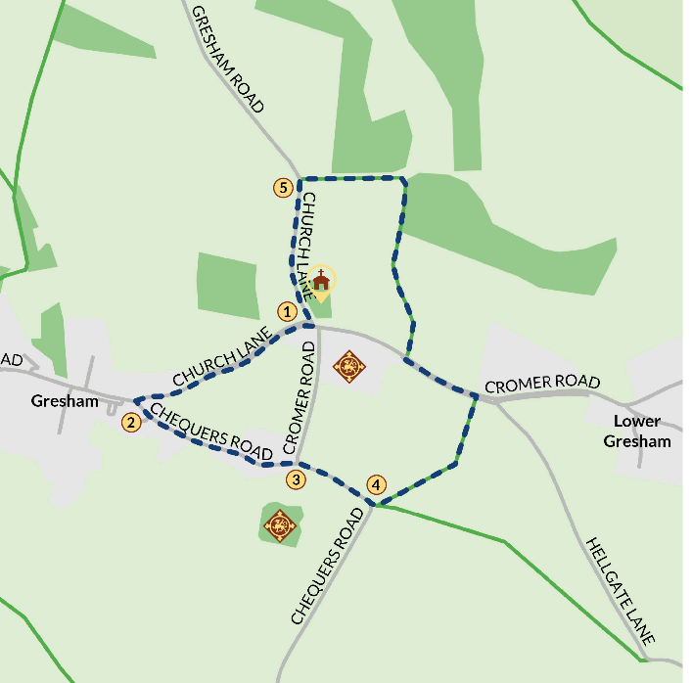
Walk to All Saints Church Gresham
Cross over from the village hall car park and turn right towards the Church. The side gateway gives passage into the churchyard. The manor of Gresham was purchased by Judge William Paston in 1427 from the Chaucer family.

Leave the church by the main gate and stop outside Gresham Village Sign
The sign includes the Paston Coat of Arms (on the left hand side of the sign). The Grasshopper on the sign is the emblem of the Gresham family and James Gresham was the local agent for the Paston family throughout the 15th century.

Turn left at Gresham Village Sign and walk along the pathway on the side of the field. After a while it turns into a pavement that follows the road (Church Lane). After about 400m turn left into Chequers Road.

Keep going down Chequers Road until you reach the junction
You will pass a corrugated iron building on the left. Watch out for any cars.
Turn right at the junction by the sign and follow the road out of the village. Where the road bends sharply to the right, turn left off the road and follow the left-hand footpath up an incline and stop at the way-marked footpath sign.

Look back at the wooded mound in the field: this was the site of Gresham Castle. The castle was besieged in 1448 by a force of 300 men belonging to Lord Moleyns and John Heydon of nearby Baconsthorpe. With her usual bravery and self-possession, a young Margaret Paston stood up to these men and instructed her husband to send her supplies to help her defend it. Margaret Paston’s letters to her husband John provide some of the most famous and vivid passages of all the Paston Letters. Margaret was eventually forced to flee to family friend John Damme’s house, a mile away at Sustead, probably taking the track to your left as you look at the castle as her escape route.

3D reconstruction of Gresham Castle
Use the phone app to explore a virtual reconstruction of Gresham Castle to imagine what life was like when it was an impressive seat of the Paston family.

Follow the public footpath across the field to a hole in the hedge
Turn left where a footpath passes through a hedge. Take a left through the hedge and walk along the side of the field until you reach the footpath that runs alongside the road. Turn left and walk along it until you reach the school car park. At the railings just before the car park, cross the road and follow the public footpath towards the woodland.

Walk along the public footpath. The hedgerow lined track will become more wooded. You are now on Fairies' Lane. Look out for a series of old oak trees on the right and one with an opening into a hollowed out space - too small for us to climb into but perhaps a Fairy home, or even for the Paston griffin?

At the end of the track, take the left-hand path up a slight incline. Pause at the end of the track by the gate to spot buzzards or red kites. Turn left and walk carefully along the road back to the church.

